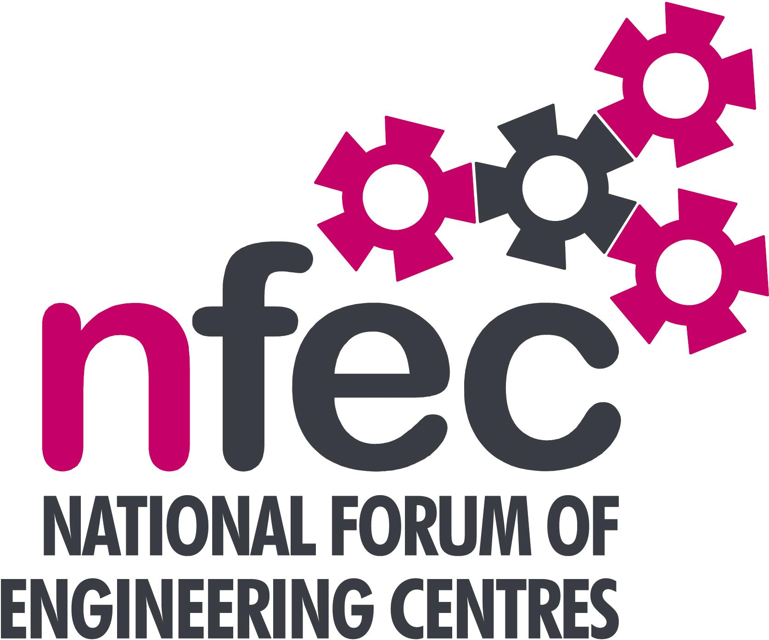
Midlands – NFEC Autumn 2019 Regional Seminar
Host: Make UK
Chair: Kevin Whitehouse

Friday 18th October 2019, 10.15am – 14.45 (Coffee from 10.00am)
Venue: Unit 6, Noble Way, Birmingham, B6 7EU
Telephone Number: 0121 344 7910

Programme

- Welcome and Introduction to the Seminar | Kevin Whitehouse (NFEC Midlands Regional Coordinator) | 10.15
- Current matters of concern relating to quality, content, structure, management and delivery of programmes of training and education in Engineering (not included on Agenda) - an opportunity for open discussion with a focus to distill key issues and plans for addressing them.  - HND to Degree Top Up opportunity  - Specialist Courses in Rail  - Delivery of HE, validation process and links with Universities  - Updates from Awarding Bodies – Current developments and general issues.  Lunch & Demonstrations by Exhibitors  - Discussions and updates on T levels, EPA, Standards and other associated areas  - Tour of the facilities at Make UK  - Plenary session – Issues to note and agreed actions for NFEC  - Date, Place and Topics for next Seminar  Close  Entry is free to this seminar for members or non-members present for a first attendance. A light buffet lunch will be provided and  you will be able to see/discuss demonstrations of the latest available equipment and facilities for the delivery of learning in Engineering. | Kevin Whitehouse / Delegates  Karl Stevens, Coventry University  Frank Dzokoto, Birmingham Metropolitan College  Kevin Whitehouse  David Lee, Bryony Leonard– Pearson  Martin Webber - OCR  Andrew Barton, Brendan Mclaughlin - EAL  Kevin Whitehouse / Bob Millington/ delegates  Kevin Whitehouse / Delegates  To book your place: Email: admin@nfec.org.uk  Phone: 07759 901229 | 10.20  10.45  11.00  11.30  11.50  13.15

